**CLOUD COMPUTING PRACTICAL 5 –Elastic Bean Stalk**

**Neha T Mathew**

Go to “Compute”service

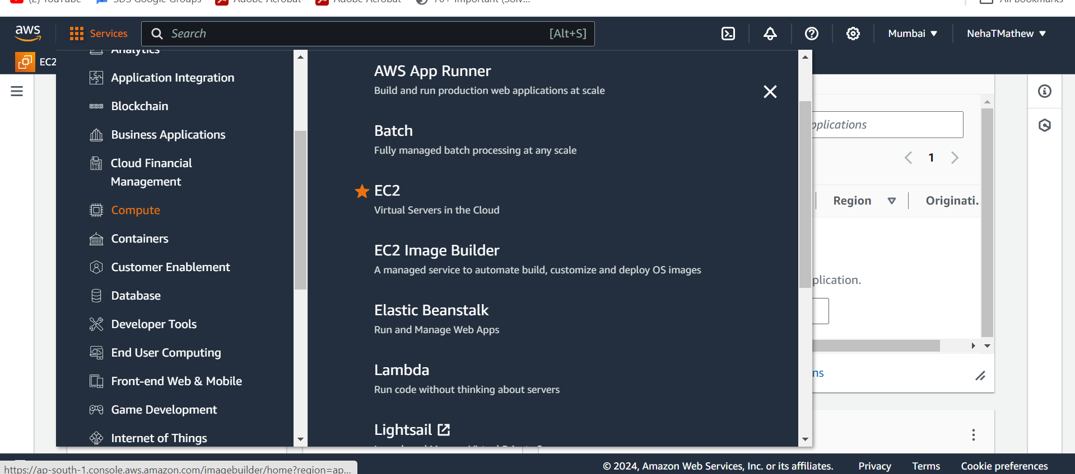

Click on Elastic Beanstalk and click on create application

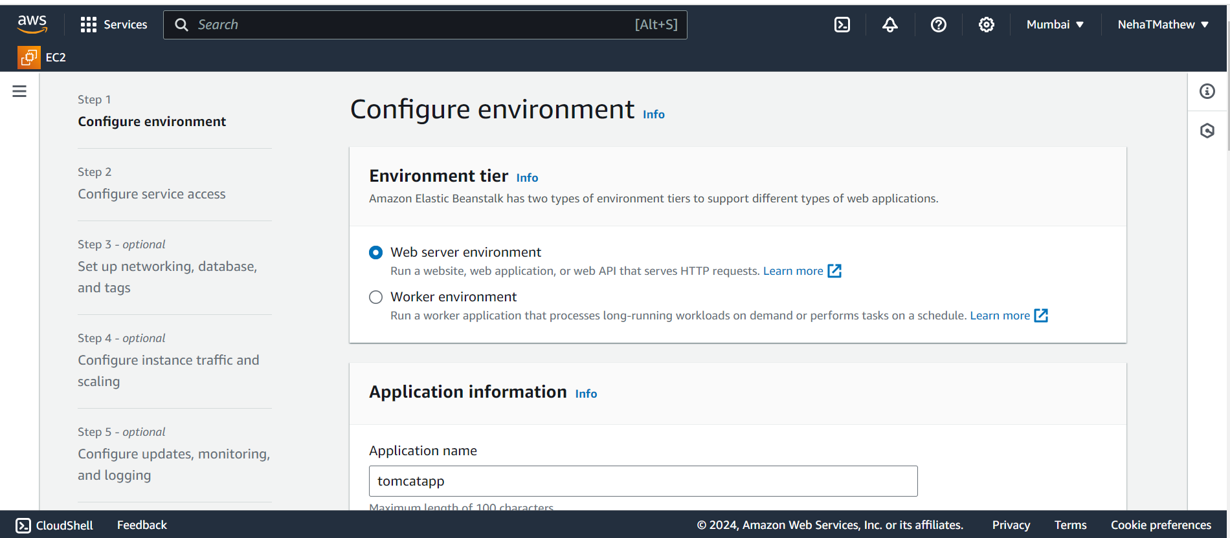

Create an application name

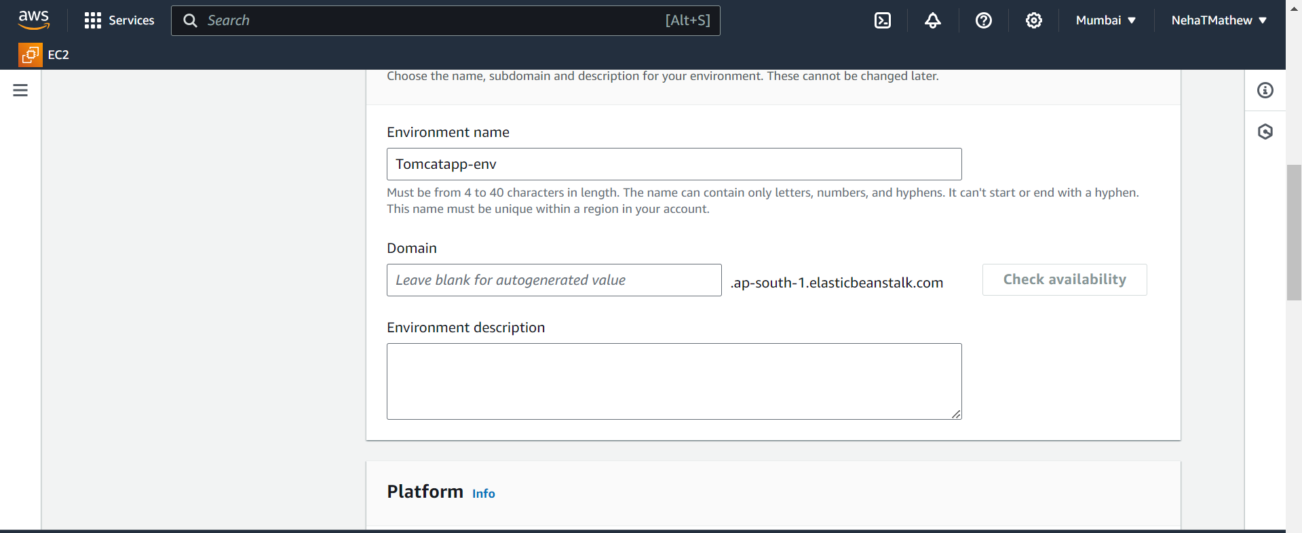

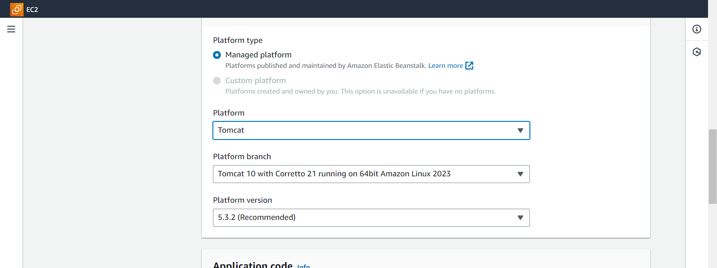

Click on upload code and local file also create a version label like “version1”

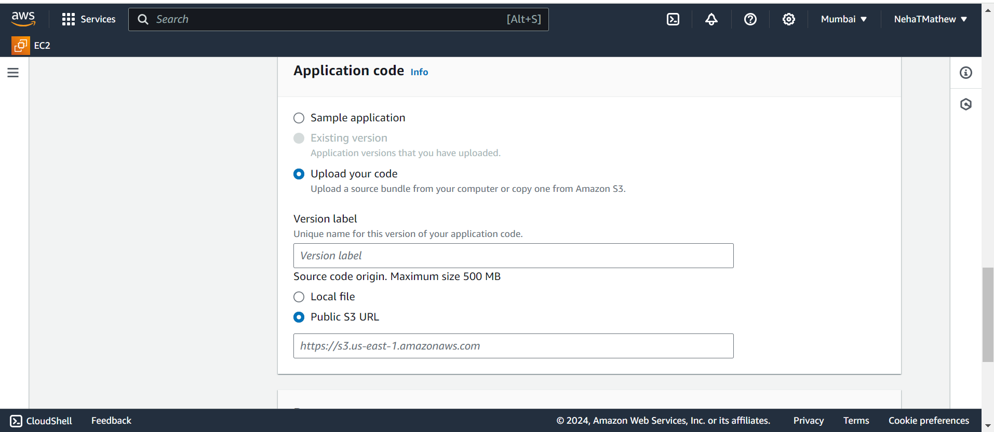

Download calendar.war from internet and upload it here

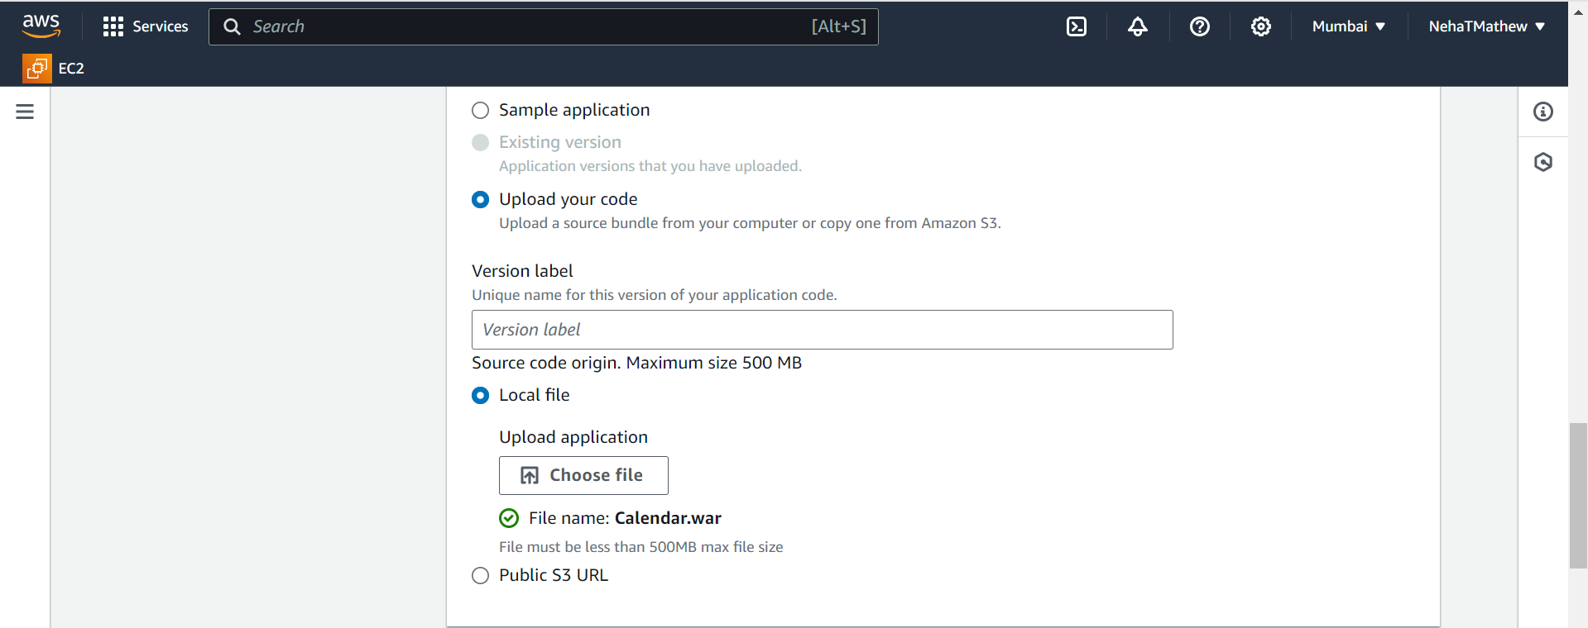

After upload click on next and then skip to review . finally click on submit

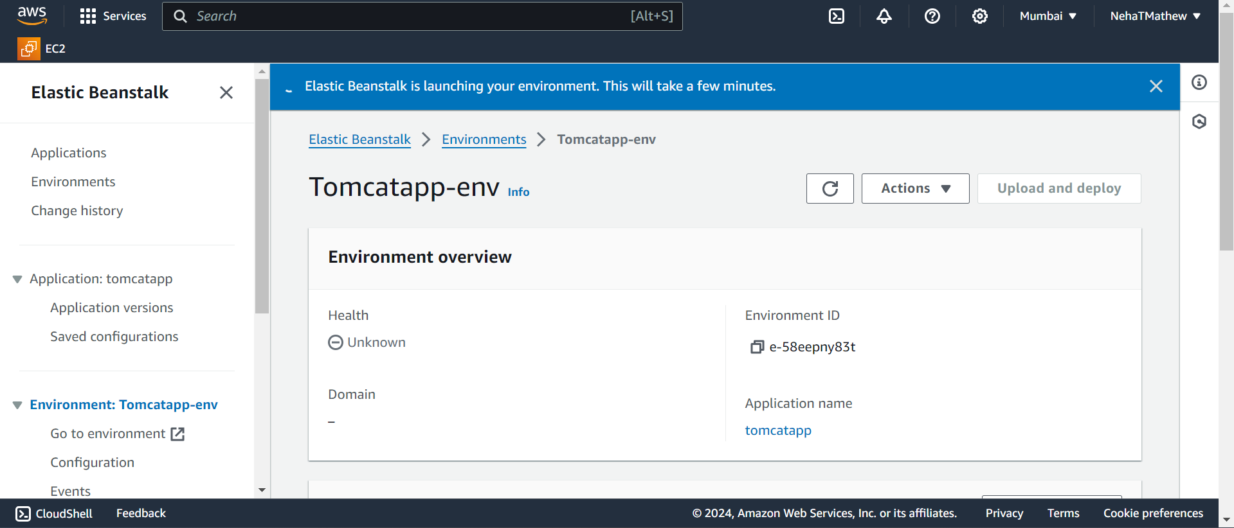

Go to configure environment

Click on create role



